
SHIRE HIGHLANDS EDUCATION DIVISION
2026 MALAWI SCHOOL CERTIFICATE OF EDUCATION MOCK
EXAMINATION
CHEMISTRY
Subject Number: M038/I
Wednesday, 25 March TimeAllowed: 2 hours
8:00 - 10:00 am

PAPER I
(100 marks)

THEORY

Instructions
- This paper contains 13 printed pages. Please check.

- Fill in your name and name of your School at the top of each page.

- This paper contains two sections, A and B. In Section A there are short answer questions while Section B there are restricted essay questions.

- Use of electronic calculators is allowed.

- The maximum number of marks for each answer is indicated against each question.

- In the table provided on this page, tick against the number of question you have answered.

- Hand in your question paper to the invigilator when time is called to stop writing.

Question Number | Tick if  answered | Do not write in these columns
1
2
3
4
5
6
7
8
9
10
11
12
13

© 2026 MASSHA SHED EXAMS Turn over

Section A (70 marks)
Answer all ten questions in this section in the spaces provided for each question.
- a. Define the term “independent variable”.
______________________________________________________________________________________________________________________________
(1mark)
b. Give one reason for controlling variables during a scientific investigation.
______________________________________________________________________________________________________________________________
(1mark)
c. Give any two ways of safely disposing of an irritating chemical waste.
______________________________________________________________________________________________________________________________
(2marks)
d. Explain how relative flow values can be used to identify the purity of a substance.
_____________________________________________________________________________________________________________________________________________________________________________________________
(2marks)
- a. State the difference between excess reagent and limiting reagent.
______________________________________________________________________________________________________________________________
(1mark)
b. Calculate the volume occupied by 14g of nitrogen gas (N₂) at standard temperature and pressure (STP). (RAM for N = 14; STP = 22.4dm³)

(3marks)
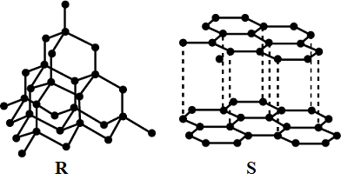
- a. Figure 1 below shows allotropes of carbon.

Figure 1
- Name allotrope R.
____________________________________________________________
(1mark)
- Explain how allotrope S is used as lubricant.
____________________________________________________________________________________________________________________________
(2marks)
- Give any two similarities between diamond and silicon dioxide.
_______________________________________________________________________________________________________________________________________________________________________________________________________________________________________________(2marks)
- Explain any one chemical property of phosphorous.
____________________________________________________________________________________________________________________________
(2marks)
- Explain the unreactive nature of nitrogen gas at room temperature.
____________________________________________________________________________________________________________________________
(2marks)
- a. The general formula of some homologous series of organic compounds are represented by the letters A, B, C and D as below:

- C_{n}H_{2n} ₊ ₁COOH B. C_{n}H_{2n} C. C_{n}H_{2n + 1}OH D. C_{n}H_{2n + 1}CHO

- Name the homologous series represented by B and D. (2marks)
B ____________________________________________________
D ____________________________________________________
- Why are compounds of homologous series C soluble in water?
______________________________________________________________________________________________________________
(2marks)
- Work out the molecular formula of a compound of homologous series A with 5 carbon atoms.

(2marks)

- Draw the structure of a compound of D with 7 carbon atoms.

(1mark)
- a. Figure 2 is a diagram showing how ethanol and ethanoic acid are produced.
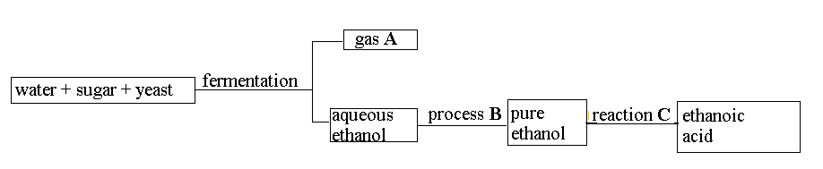
Figure 2
- Name gas A: _____________________________________________
(1mark)
- Give the name of process B: ________________________________
(1mark)
- Explain reaction C.
____________________________________________________________________________________________________________________
(2marks)
b. Explain any two classes of alkanols.
____________________________________________________________________________________________________________________________________________________________________________________________________________________________________________________________
(4marks)
- a. State the difference between temporary water hardness and permanent water hardness.
_____________________________________________________________________________________________________________________________________________________________________________________________
(1mark)
b. With the aid a chemical equation, describe the removal of water hardness using precipitation method.
___________________________________________________________________________________________________________________________________________________________________________________________________________________________________________________________________________________________________________________________
(4marks)
c. Explain any one importance of the water cycle.
____________________________________________________________________________________________________________________________________________________________________________________________________________________________________________________________
(2marks)
- a. Differentiate theoretical yield from actual yield of a chemical reaction.
_____________________________________________________________________________________________________________________________________________________________________________________________
(1mark)
b. In a chemical reaction, 9.5g of zinc reacts with silver chloride solution to produce 4.22g of silver according to the chemical equation:
Zn (s) + 2AgCl (aq) ZnCl₂ (aq) + 2Ag (s)

- Work out the theoretical yield of silver. (RAM for Zn = 65, Ag = 108, Cl = 35.5)

(4marks)
- Calculate the percentage yield of silver.

(2marks)
- a. Differentiate strength from concentration of a base.
______________________________________________________________________________________________________________________________
(1mark)
b. Write two conjugate acid – base pairs in the following chemical equation:
HNO₃ (aq) + NH₃ (aq) NH⁺ (aq) + NO₃⁻
______________________________________________________________________________________________________________________________
(2marks)
c. Draw all structural isomers of pentanal, C₄H₉CHO

(3marks)
- Explain the effect of branching on the boiling point of organic compounds.
________________________________________________________________________________________________________________________________________________________________________________________________________________________________________________________
(3marks)
- a. State any one use of oxidation number.
____________________________________________________________________________________________________________________________________
(1mark)
b. Give any one factor that affect preferential discharge of ions at the electrodes.
________________________________________________________________
(1mark)
c. Figure 3 shows electrolysis of 500ml of dilute sodium iodide (NaI) solution.
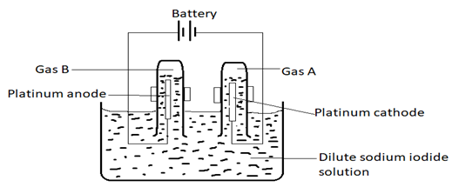
Figure 3
- Write down the ions which are being preferentially discharged at the electrodes.
________________________________________________________
(2marks)
- Identify gas A
________________________________________________________
(1mark)
- Write an ionic equation to show the reaction at the anode.
____________________________________________________________________________________________________________________
(2marks)
- a. Calculate the electromotive force (emf) of an electrochemical cell made from magnesium and silver: Mg (s)│Mg²⁺ (aq)││2Ag⁺ (aq)│2Ag (s) given that:
Mg (s)│Mg²⁺ (aq), Ꜫ^{Ө} = - 2.3 6V
Ag (s)│Ag⁺ (aq), Ꜫ^{Ө} = + 0.80V

(3marks)
b. Define the term “condensation polymerisation”.
__________________________________________________________________________________________________________________________________________
(1mark)
c. Explain any one way of mitigating the effects of global warming.
__________________________________________________________________________________________________________________________________________
(2marks)
Section B (30 marks)
Answer all the three questions in this section in the spaces provided.
- a. Describe a test for chlorine gas
________________________________________________________________________________________________________________________________________________________________________________________________________________________________________________________________________________________________________________________________________________________________________________________________________________________________________________________________________________________________________________________
(4marks)
b. Describe any three social and economic importance of recycling wastes
__________________________________________________________________________________________________________________________________________________________________________________________________________________________________________________________________________________________________________________________________________________________________________________________________________________________________________________________________________________________________________________________________________________________________________________________________________________________________________________________________________________________________________________________________________________________________________________________________________________________________________________________________________________________________________________
(6marks)

- Describe an experiment that can be conducted to identify basic oxides, acidic oxides and amphoteric oxides.
___________________________________________________________________________________________________________________________________________________________________________________________________________________________________________________________________________________________________________________________________________________________________________________________________________________________________________________________________________________________________________________________________________________________________________________________________________________________________________________________________________________________________________________________________________________________________________________________________________________________________________________________________________________________________________________________________________________________________________________________________________________________________________________________________________________________________________________________________________________________________________________________________________________________________________________________________________________________________________________________________________________________________________________________________________________________________________________________________________________________________________________________________________________________________________________________________________________________________________________________________________________________________________________________________________________________________________________________________________________________________________________________________________________________________________________________________________________________________________________________________________________________________________________________________________________________________________________________________________________________________________________________________________________________________________________
(10 marks)
- Describe the production of an insoluble salt of barium sulphate (BaSO₄) from solid barium chloride (BaCl₂) and solid sodium sulphate (Na₂SO₄) salts using precipitation method. Include a net ionic equation in the description.
___________________________________________________________________________________________________________________________________________________________________________________________________________________________________________________________________________________________________________________________________________________________________________________________________________________________________________________________________________________________________________________________________________________________________________________________________________________________________________________________________________________________________________________________________________________________________________________________________________________________________________________________________________________________________________________________________________________________________________________________________________________________________________________________________________________________________________________________________________________________________________________________________________________________________________________________________________________________________________________________________________________________________________________________________________________________________________________________________________________________________________________________________________________________________________________________________________________________________________________________________________________________________________________________________________________________________________________________________________________________________________________________________________________________________
(10 marks)
END OF QUESTION PAPER
This paper contains 13 printed pages.

